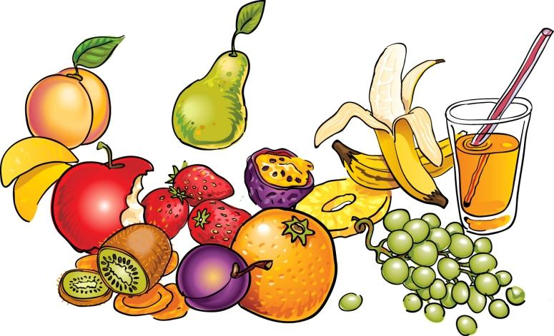 CHILDRENS MENU 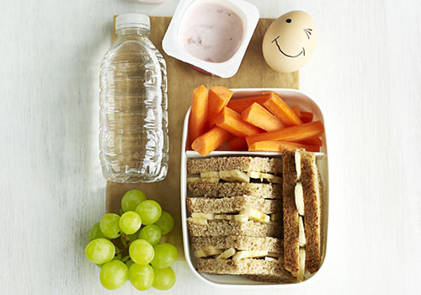  Up to 11 years old  With the exception of baby food we would appreciate  that all food is purchased from our coffee shop, THANK YOU  SMALL SOUP OF THE DAY - £2.25 - KIDS COMBO - £4.50  VARIETY BASKET - £3.99 (5 ITEMS IN TOTAL)  STEP 1  PLEASE LET YOU SERVER KNOW WHICH SANDWICH FILLING  YOU WOULD LIKE FROM THE FOLLOWING SELECTION  AND IT WILL BE FRESHLY MADE FROM THE KITCHEN ON WHITE BREAD  (CHEDDAR CHEESE , EGG OR TUNA MAYONNAISE, ROAST BEEF,  CHICKEN BREAST MAYONNAISE, PLAIN CHICKEN BREAST OR JAM)  STEP 2  THEN CHOOSE 4 REMAINING ITEMS FROM THE FRIDGE AND  WINDOW SILL AREA, LOCATED NEXT TO THE TILL.  *-YOGHURT, *-ITEM OF FRESH FRUIT, *-CHOCOLATE FREDDO,  *- CHEESE PORTION *- POMBEAR CRISPS, *-JUICE/WATER/MILKSHAKE  PASTA IN A CHEESE SAUCE - £3.99  SMALL BAKED POTATO WITH A CHOICE OF FILLING - £3.99  (CHEDDAR CHEESE, TUNA OR EGG MAYONNAISE,  CHICKEN BREAST OR HEINZ BAKED BEANS)  KIDS SANDWICH - £3.99  (CHEDDAR CHEESE, TUNA OR EGG MAYONNAISE, HONEY ROAST HAM,  CHICKEN BREAST MAYONNAISE, PLAIN CHICKEN OR JAM –  SERVED ON EITHER FRESH WHITE OR BROWN BREAD  WITH SALAD AND CRISPS)  SMALL PORTION OF THE DAILY MAIN COURSE SPECIAL -£3.99  (PLEASE SEE CHALKBOARD)  MACKIES ICE CREAM TUB- £1.40 – (TRADITIONAL)  BLACKCURRANT RIBENA - £1.30  SMALL BOTTLED WATER - £0.60 | CHILDRENS MENU  Up to 11 years old  With the exception of baby food we would appreciate  that all food is purchased from our coffee shop, THANK YOU  SMALL SOUP OF THE DAY - £2.25 - KIDS COMBO - £4.50  VARIETY BASKET - £3.99 (5 ITEMS IN TOTAL)  STEP 1  PLEASE LET YOU SERVER KNOW WHICH SANDWICH FILLING  YOU WOULD LIKE FROM THE FOLLOWING SELECTION  AND IT WILL BE FRESHLY MADE FROM THE KITCHEN ON WHITE BREAD  (CHEDDAR CHEESE , EGG OR TUNA MAYONNAISE, ROAST BEEF,  CHICKEN BREAST MAYONNAISE, PLAIN CHICKEN BREAST OR JAM)  STEP 2  THEN CHOOSE 4 REMAINING ITEMS FROM THE FRIDGE AND  WINDOW AREA, LOCATED NEXT TO THE TILL.  *-YOGHURT, *-ITEM OF FRESH FRUIT, *-CHOCOLATE FREDDO,  *- CHEESE PORTION *- POMBEAR CRISPS, *-JUICE/WATER/MILKSHAKE  PASTA IN A CHEESE SAUCE - £3.99  SMALL BAKED POTATO WITH A CHOICE OF FILLING - £3.99  (CHEDDAR CHEESE, TUNA OR EGG MAYONNAISE,  CHICKEN BREAST OR HEINZ BAKED BEANS)  KIDS SANDWICH - £3.99  (CHEDDAR CHEESE, TUNA OR EGG MAYONNAISE, HONEY ROAST HAM,  CHICKEN BREAST MAYONNAISE, PLAIN CHICKEN OR JAM –  SERVED ON EITHER FRESH WHITE OR BROWN BREAD  WITH SALAD AND CRISPS)  SMALL PORTION OF THE DAILY MAIN COURSE SPECIAL -£3.99  (PLEASE SEE CHALKBOARD)  MACKIES ICE CREAM TUB- £1.40 – (TRADITIONAL)  BLACKCURRANT RIBENA - £1.30  SMALL BOTTLED WATER - £0.60

